Image Segmentation
Code:
import cv2
import numpy as np
import matplotlib.pyplot as plt
image = cv2.imread('tarkan.jpg')
gray = cv2.cvtColor(image, cv2.COLOR_BGR2GRAY)
blur = cv2.GaussianBlur(gray, (5, 5), 0)
_, thresh = cv2.threshold(blur, 0, 255, cv2.THRESH_BINARY + cv2.THRESH_OTSU)
contours, _ = cv2.findContours(thresh, cv2.RETR_EXTERNAL, cv2.CHAIN_APPROX_SIMPLE)
segmented = image.copy()
cv2.drawContours(segmented, contours, -1, (0, 255, 0), 2)
plt.figure(figsize=(12, 6))
plt.subplot(1, 2, 1)
plt.title("Original Image")
plt.imshow(cv2.cvtColor(image, cv2.COLOR_BGR2RGB))
plt.axis('off')
plt.subplot(1, 2, 2)
plt.title("Segmented Image")
plt.imshow(cv2.cvtColor(segmented, cv2.COLOR_BGR2RGB))
plt.axis('off')
plt.show()
cv2.imwrite('segmented_tarkan.jpg', segmented)
Code Explanation
- Importing Required Libraries:
  - OpenCV for image processing.
  - NumPy for numerical operations.
  - Matplotlib for visualization.
- Preprocessing:
  - Convert to Grayscale: Simplifies the image to a single channel for easier thresholding.
  - Gaussian Blur: Reduces noise and smooths the image for better segmentation.
- Thresholding:
  - Otsu’s Binarization: Dynamically determines the optimal threshold value to separate foreground and background.
- Contour Detection:
  - Contours are extracted from the binary image to identify distinct objects or regions.
- Drawing Contours:
  - The contours are overlaid on the original image to highlight the segmented regions.
- Visualization and Saving:
  - Displays the original and segmented images side by side and saves the segmented image to a file.
Report
Objective
To perform image segmentation on the input image tarkan.jpg using OpenCV to identify distinct regions or objects in the image.
Process
- Input Analysis:
  - The input image is read in color and converted to grayscale for simplification.
  - Noise is reduced with Gaussian Blur, enhancing thresholding accuracy.
- Segmentation:
  - Otsu’s Binarization separates the foreground (objects) from the background.
  - Contours of segmented regions are identified and drawn on the original image.
- Output Analysis:
  - Segmented regions are highlighted with green contours.
  - Visual comparison confirms the effectiveness of the segmentation process.
Results
- The segmented image, saved as segmented_tarkan.jpg, shows clear contours around distinct regions in the image.
- Segmentation effectively delineates objects in the image.
Recommendations
- Experiment with different smoothing techniques (e.g., median blur) for better results in noisy images.
- For complex images, consider advanced segmentation techniques like k-means clustering or watershed algorithms.

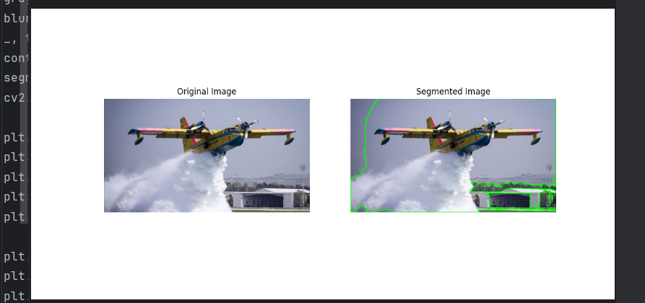
Output:

